Driving Directions to UCSD, EDS/Pepper Canyon Hall

* Take I-5 to the La Jolla Village Drive Exit.

* Exit and head west on La Jolla Village Dr.

* Take the 1st right onto Villa La Jolla Dr.

* Villa La Jolla Dr. ends at the Gilman Parking Structure. Proceed into the parking structure, and park in any unreserved space marked with a V. Permit machines are located by the main structure exits. Purchase a permit and then place it in plain sight on your dashboard. Parking enforcement patrols regularly so make sure to get enough time on your pass.

Directions to EDS/Pepper Canyon Hall from the Gilman Parking Structure

* The Education Studies Program is located on the 3rd Floor of Pepper Canyon Hall just north of the Gilman Parking Structure on Russell Drive.

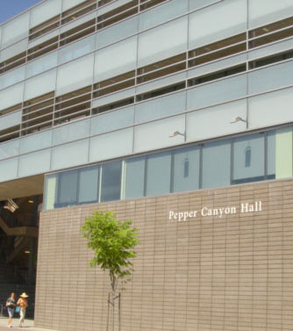

An interactive campus map can be found here: UC San Diego Campus Map

